|  |  |  |  |  |
| --- | --- | --- | --- | --- |
| EGC_Black | | Mathematics Essentials 2017  Unit 2 Test 1  Task Weighting: 8% | | |
| Student Name: |  | | TOTAL 51 Marks MmMarks |

Time Allowed: 15 Minutes Marks: 15

**Calculator Free** **No calculator or notes permitted for this section.**

**Question 1** [3 Marks]

Complete the table by choosing the most appropriate Data Display and Data Type from the options provided.

**Data Type**

* Numerical
* Categorical

**Data Display**

* Column graph
* Dot frequency diagram
* Back to back stem and leaf diagram
* Histogram
* Box & whisker Plot

|  |  |  |
| --- | --- | --- |
|  | **Data Display** | **Data Type** |
| The heights (measured in cm) of 20 boys and 20 girls to compare them. |  |  |
| The eye colour of all Year 11 students. |  |  |
| The foot length, measured in cm, of the members of your class |  |  |
| House prices in various suburbs |  |  |
| The birth month of all Essentials students. |  |  |

**Question 2** [4 marks: 2, 2]

Two classes are marked on the same tests.

* Class P has a mean of 65% and standard deviation of 5.
* Class Q has a mean of 50% and standard deviation of 15.

1. Which class performed better and why?

1. Write a statement comparing the spread of the scores for the two classes and justify your comment.

**Question 3** [ 4 marks]

The number of break-and-enter offences in a rural city were recorded over a number of months.

21, 25, 17, 23, 16, 21, 41, 22, 25, 20, 22, 11, 20, 12, 13, 12, 6, 12, 10, 19, 30, 22, 21, 14, 34, 33, 34

Draw a boxplot for this data on the grid below.



**Question 4** [4 marks – 2, 2]

1. Describe the distribution below.

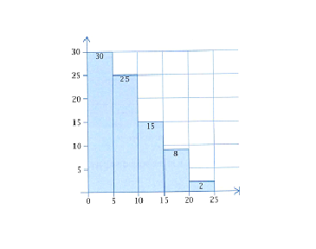

1. Give an example of what data could be represented in this graph and justify your answer.

End of Calculator Free Section

Time Allowed: 40 Minutes Marks: 36

**Calculator Assumed - Calculators and files are allowed in this test.**

***Show all working to maximise marks.***

**Question 5** [7 marks: 1, 1, 1, 2, 1, 1 ]

This dot plot shows the number of births in the Goldfields region of Western Australia recorded each month for one year.

**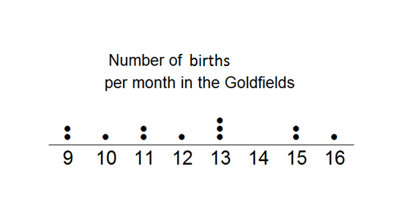**

a) What type of data is represented in this graph?

b) Calculate the range of the scores, showing your working.

c) Determine the mode. \_\_\_\_\_\_\_\_\_\_\_\_\_\_\_\_\_\_

d) Determine the median. \_\_\_\_\_\_\_\_\_\_\_\_\_\_\_\_\_\_

e) Calculate the mean, showing your working.

f) Complete this sentence:   
For the Goldfields region, you would expect approximately \_\_\_\_\_\_\_\_\_\_ births per month.

**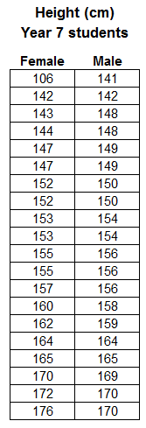Question 6** [13 marks: 2, 2, 3, 4, 2]

Consider the data to the right, showing the heights of 20 male and 20 female Year 7 students, taken from CensusAtSchool.

1. Identify any outliers in the data.
   1. For any you find, explain why you consider it an outlier.
2. Explain the effect the outlier(s) have on the:
   1. Mean
   2. Median

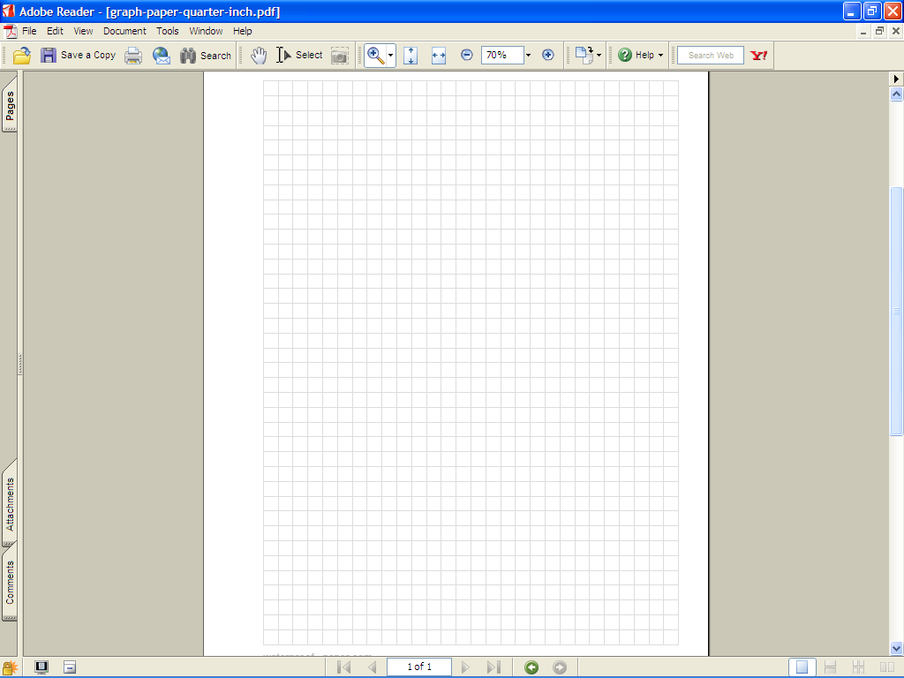

1. Make a back-to-back stem and leaf diagram to display this data.
2. Complete the table below, showing your working, to summarize the statistics for this data.

|  |  |  |
| --- | --- | --- |
| **Statistic** | **Female** | **Male** |
| Mode |  |  |
| Median |  |  |
| Range |  |  |
| Mean |  |  |

1. Using your stem and leaf plot and/or the table in d), compare the data for males and females.
2. Which average is best and and justify your choice.

### Question 7 [10 marks: 1, 5, 2, 2]

a) Eric is in Class A, he scored 5 on the test. **Label** **the two box plots** with their class names.

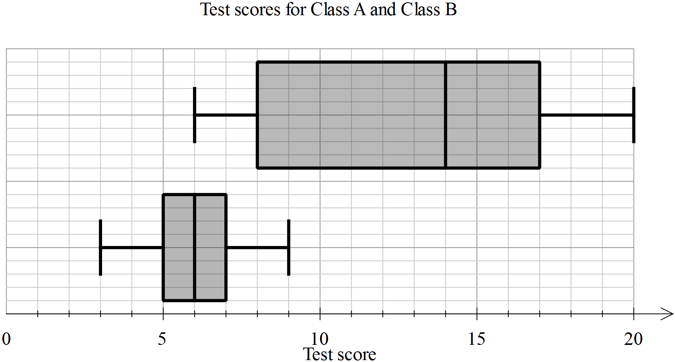

b) Use the table below to enter the appropriate values for each of the plots.

|  |  |  |
| --- | --- | --- |
| **Statistic** | **Class A** | **Class B** |
| Minimum |  |  |
| First quartile |  |  |
| Median |  |  |
| Third quartile |  |  |
| Maximum |  |  |

c) Calculate the range and interquartile range for each class, showing the working, in the table below.

|  |  |  |
| --- | --- | --- |
| **Statistic** | **Class A** | **Class B** |
| Range |  |  |
| Interquartile range |  |  |

1. In each of the statements below, write A and B as appropriate to make the statement true.

* Class \_\_\_\_\_\_ has a much greater range than Class \_\_\_\_\_\_
* The minimum for Class \_\_\_\_\_\_ is the same as the median for Class \_\_\_\_\_\_
* For Class \_\_\_\_\_\_, the data is symmetrical and for Class \_\_\_\_\_\_, 100% of the scores are greater than 6.

### Question 8 [6 marks]

The frequency table for the heights of a group of soccer players is given below.

Graph this information below.

|  |  |
| --- | --- |
| Height | Frequency |
| 175 up to 180 | 3 |
| 180 up to 185 | 1 |
| 185 up to 190 | 12 |
| 190 up to 195 | 7 |
| 195 up to 200 | 4 |
| 200 up to 205 | 3 |



End of Test